Lesson #10: Unhandled Exceptions

Part 1 — Goal and Vulnerability Summary
This lesson demonstrates an Unhandled Exceptions vulnerability in the DVSA-ORDER-GET Lambda function. When a client requests order details using the get action, the backend Python Lambda (get_order.py) crashes with an AttributeError because a boolean value from DynamoDB is passed to .lower() without type checking. The unhandled exception causes the Lambda to return an HTTP 500 error with a stack trace that leaks the internal file path /var/task/get_order.py and the exact line number. The root cause is missing input validation and exception handling in the server-side code. The security impact includes information leakage through verbose error responses and denial of service for legitimate users trying to view order details.

Part 2 — Why This Works / Root Cause
The root cause is that the get_order.py Lambda function performs:

is_admin = json.loads(event.get("isAdmin", "false").lower())

without first verifying that the value is a string. When DynamoDB or the frontend sends isAdmin as a boolean (False) rather than a string ("false"), calling .lower() on a bool raises AttributeError: 'bool' object has no attribute 'lower'. Because no try/except block handles this exception, the Lambda crashes and returns the full stack trace in the response body, leaking the internal file path /var/task/get_order.py and line 32.

Part 3 — Environment and Setup

Item | Details
DVSA URL | http://dvsa-website-test-207791567927-us-east-1.s3-website.us-east-1.amazonaws.com
Endpoint / Function | POST /dvsa/order | DVSA-ORDER-GET (Lambda) — get_order.py handler
IAM Role / Log Group | /aws/lambda/DVSA-ORDER-GET
Tools | Browser DevTools (Network + Payload + Response tabs), AWS Lambda Console
User Context | Authenticated user — regular user viewing own order detail
AWS Region | us-east-1 (N. Virginia)

Part 4 — Reproduction Steps
- Log in as a regular user, navigate to the My Orders page, and click on order 7c4e48c7-5de9-406c-aa97-7cc65ac882a9 to trigger the order detail view.
- Open Browser DevTools (Network tab) and observe the POST /dvsa/order request sent with payload: {"action": "get", "order-id": "7c4e48c7-5de9-406c-aa97-7cc65ac882a9"}.
- Observe that the Response tab returns the full error with body: {"errorMessage": "'bool' object has no attribute 'lower'", "errorType": "AttributeError", "stackTrace": ["File /var/task/get_order.py, line 32..."]}. The order detail page fails to load — all fields show as blank.
- Confirm the vulnerability is consistent: every attempt to load any order detail triggers the same error, making the order detail feature completely unavailable.

Part 5 — Evidence and Proof

Figure 1 — Order page with blank fields BEFORE fix
The order detail page fails to load. All fields (Order Status, Confirmation Token, Date, Address, Total) show as blank. The order ID 7c4e48c7-5de9-406c-aa97-7cc65ac882a9 is visible in the URL confirming this is the attacker's own order.
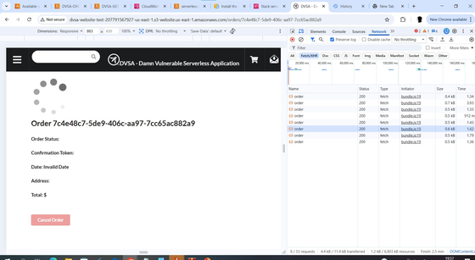
Figure 1: Order detail page — all fields blank, order ID 7c4e48c7-5de9-406c-aa97-7cc65ac882a9 in URL, loading spinner visible

Figure 2 — DevTools Response tab showing full stack trace
The Response tab reveals the complete error including internal file path and line number:
- errorMessage: 'bool' object has no attribute 'lower'
- errorType: AttributeError
- stackTrace: File "/var/task/get_order.py", line 32, in lambda_handler
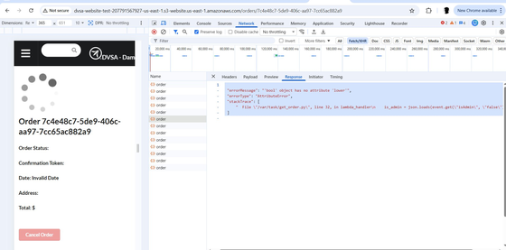
Figure 2: DevTools Response tab showing full stack trace — errorMessage: 'bool' object has no attribute 'lower', errorType: AttributeError, internal file path /var/task/get_order.py line 32 leaked

Part 6 — Fix Strategy / Probable Mitigation
The fix belongs in the get_order.py Lambda handler inside DVSA-ORDER-GET. The isAdmin value retrieved from the event must be coerced to a string before calling .lower():

is_admin = str(event.get('isAdmin', 'false')).lower()

This addresses the root cause because it eliminates the type mismatch crash. The str() cast safely converts both boolean False and string 'false' to the string 'false' before calling .lower(), preventing the AttributeError entirely.

Part 7 — Code / Config Changes
Location of fix:
- Lambda function: DVSA-ORDER-GET
- File: get_order.py — line 32 in lambda_handler

Before / After comparison:

BEFORE (Vulnerable) | AFTER (Fixed)
is_admin = json.loads(event.get("isAdmin", "false").lower()) # BUG: crashes if isAdmin is bool | is_admin = json.loads(str(event.get("isAdmin", "false")).lower()) # FIXED: cast to str first

Full fix in context:
# VULNERABLE CODE (before fix)
# Crashes with AttributeError when isAdmin is boolean False
# is_admin = json.loads(event.get("isAdmin", "false").lower())

# FIX: cast to str() first before calling .lower()
# Safely handles both string "false" and boolean False
is_admin = json.loads(str(event.get("isAdmin", "false")).lower())

Part 8 — Verification After Fix
After deploying the fix, the order detail page was refreshed.

Figure 3 — Order page loading correctly AFTER fix
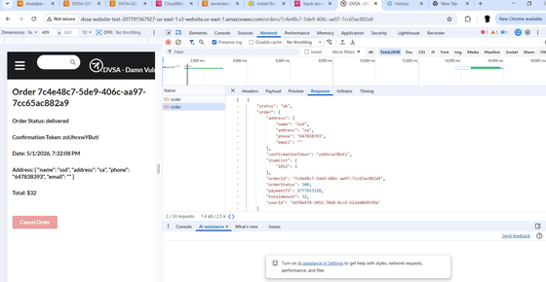
Figure 3: Order detail page after fix — all fields populated correctly (Order Status: delivered, Confirmation Token, Date, Address, Total: $32). HTTP 200 returned with full order data.

What changed: The Lambda no longer crashes when isAdmin is a boolean. The str() cast ensures .lower() is always called on a string, eliminating the AttributeError and allowing the order detail to load successfully with all fields populated.

Legitimate behavior still works: A logged-in user can now view their order detail page successfully with all fields (Order Status, Confirmation Token, Date, Address, Total) populated correctly.

Part 9 — Structured Operation and Security Analysis
9a. Intended Logic and Security Rule(s)
The intended logic is: an authenticated user requests order details by submitting POST /dvsa/order with action: "get" and an order-id. The get_order.py Lambda retrieves the order from DynamoDB and returns the order details. The system MUST handle all data types returned from DynamoDB gracefully.

- Security Rule 1: The system MUST validate and cast all input fields to expected types before processing.
- Security Rule 2: All Lambda handlers MUST wrap execution in try/except blocks and return controlled error responses without leaking stack traces.

9b. Evidence Sources and Behavior Trace

Case | Observed Behavior | Evidence / Source
Normal (Legitimate user) | Order detail page loads with all fields populated (status, confirmation, date, address, total). | Browser DevTools: POST /dvsa/order returns HTTP 200 with full order object.
Exploit (Attacker) | Order detail page fails to load; all fields are blank. HTTP 500 returned with 'Request processing failed'. | Browser DevTools Response: errorMessage: 'bool' object has no attribute 'lower', errorType: AttributeError. Internal file path /var/task/get_order.py line 32 leaked.
Post-Fix | Order detail page loads successfully after applying str() cast fix; no more 500 errors. | Browser DevTools: HTTP 200 with full order data. No TypeError in CloudWatch logs.

9c. Deviation Analysis and Classification
Rule Violated | Evidence of Violation | Deviation Classification
All Lambda handlers MUST validate and cast input types; unhandled exceptions MUST NOT propagate as 500 errors. | CloudWatch TypeError stack trace in get_order.py line 32; HTTP 500 response with stack trace leaked in DevTools Response tab. | Accidental misconfiguration — developer omitted type coercion for isAdmin field before calling .lower().

9d. Explainable Fix and Post-Fix Validation
(1) Wrong assumption: isAdmin would always be a string; .lower() was called without checking the type. (2) Fix location: get_order.py line 32 in lambda_handler inside DVSA-ORDER-GET. (3) Change made: replace json.loads(event.get("isAdmin","false").lower()) with json.loads(str(event.get("isAdmin","false")).lower()). (4) Post-fix: order detail loads correctly with HTTP 200; no AttributeError. Legitimate behavior confirmed working.

Standard Summary Tables

Table A — Structured Analysis Summary

Vulnerability | Intended Rule(s) | Artifacts Used | Normal Behavior Evidence | Exploit Behavior Evidence
Lesson #10: Unhandled Exceptions | Rule 1: Input types MUST be validated before use. Rule 2: Lambda handlers MUST handle all exceptions and return controlled responses without leaking stack traces. | Browser DevTools (payload, response tabs), get_order.py source code, order detail page behavior | POST /dvsa/order with get action returns HTTP 200 and full order object for valid order-id. | Same request returns HTTP 500 with full stack trace: errorMessage: 'bool' object has no attribute 'lower', leaking /var/task/get_order.py line 32.

Table B — Structured Analysis Summary

Vulnerability | Why This Is a Deviation | Deviation Class | Fix Applied (Where) | Post-Fix Verification | Optional Logging
Lesson #10: Unhandled Exceptions | A standard user request triggers a server crash because isAdmin is a boolean the handler fails to validate the type, violating the rule that all input must be type-safe before processing. | Accidental misconfiguration | Cast isAdmin to str() before .lower() in get_order.py line 32 inside DVSA-ORDER-GET Lambda. Deployed fix. | Order detail returns HTTP 200 with full data after fix. No AttributeError. All fields populated correctly. | N/A

Part 10 — Takeaway / Lessons Learned
This vulnerability demonstrates that unhandled exceptions in serverless Lambda functions create two distinct risks: denial of service (the feature becomes completely unavailable) and information leakage (stack traces in responses reveal internal file paths and logic). In a serverless context this is especially dangerous because Lambda functions are stateless and auto-scaling — a crash affects every concurrent invocation. The core lesson is: all Lambda handlers must validate input types defensively before use. Never assume that data arriving from DynamoDB or the frontend will always be the expected type — always cast and validate before calling type-specific methods. A simple str() cast before .lower() would have entirely prevented this vulnerability.

